[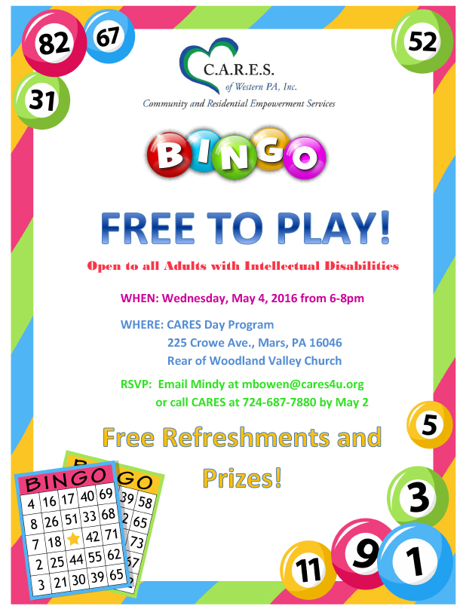](http://www.google.com/url?sa=i&rct=j&q=&esrc=s&source=images&cd=&cad=rja&uact=8&ved=0ahUKEwi03vGt_NLYAhXkguAKHffyBkkQjRwIBw&url=http://cares4u.org/news-and-events/&psig=AOvVaw0qkusuSsC4Wm3Y_0dDHDmF&ust=1515865247861504)

For more information or to purchase tickets contact Building Blocks of Faith at (301) 752-9802 or [bbfschool@hotmail.com](mailto:bbfschool@hotmail.com).

**Coach Purse Bingo**

**Hosted by Building Blocks of Faith Preschool**

**Saturday, February 23rd at 1:00pm, doors open at 12:00pm.**

**Location: Mechanicsville Moose Lodge**

**27636 Mechanicsville Road, Mech, MD**

Presale tickets will go on sale Monday, February 4th for $30. Tickets will also be available at the door for $35.

(admission includes 1 set of regular games.)

*Raffle *Silent Auction

*Extra games/specials available for purchase

*Refreshments will be available for purchase